- Tên và phân loại:

- Mục đích, ý nghĩa:
- Specify the kinds of objects to create using a prototypical
instance, and create new objects by copying this prototype
- Động lực sử dụng:
- Framework implements Graphic class for graphical components and
GraphicTool class for tools manipulating/creating those components
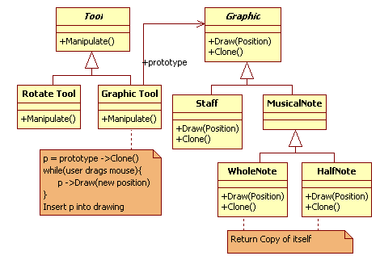
- Khi nào sử dụng:
- When the classes to instantiate are specified at run-time, for
example, by dynamic loading
- To avoid building a class hierarchy of factories that parallels
the class hierarchy of products
- When instances of a class can have one of only a few
different combinations of state. It may be more convenient to
install a corresponding number of prototypes and clone them
rather than instantiating the class manually, each time with
the appropriate state
- Cấu trúc
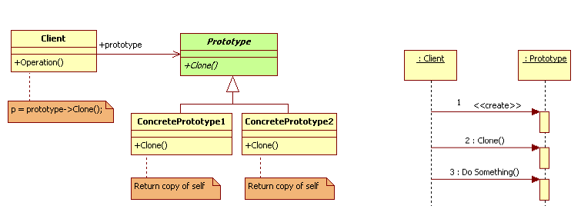
- Các thành viên - Sự cộng tác
- Prototype: declares an interface for cloning itself
- ConcretePrototype: implements an operation for cloning itself
- Client: creates a new object by asking a prototype to clone
itself
- Các hệ quả mang lại:
- Adding and removing products at run-time
• Let you incorporate a new concrete product class into a system
simply by registering a prototypical instance with the client. That's
a bit more flexible than other creational patterns, because a
client can install and remove prototypes at run-time
- Specifying new objects by varying values
• Highly dynamic systems let you define new behavior through
object composition (for example – by specifying values for an
object's variables) and not by defining new classes.
• You effectively define new kinds of objects by instantiating
existing classes and registering the instances as prototypes of
client objects
• A client can exhibit new behavior by delegating responsibility to
the prototype
- Specifying new objects by varying structure
• Many applications build objects from parts and subparts (For
example, Editors for circuit design)
- Configuring an application with classes dynamically
• Some run-time environments let you load classes into an
application dynamically
• The key to exploiting such facilities in a language like C++
- Chú ý liên quan đến cài đặt:

- Hệ thống thực tế

- Mẫu liên quan
- Prototype and Abstract Factory are competing patterns in
some ways. However, they can also be used together
• An Abstract Factory might store a set of Prototypes from which to
clone and return product objects
- Designs that make heavy use of the Composite and Decorator
patterns often can benefit from Prototype as well

